

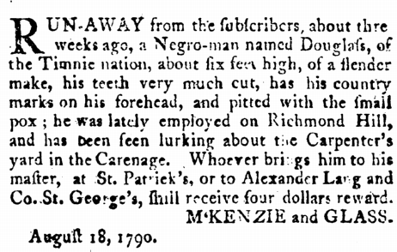

- An enslaved fugitive named ‘Douglas’ with ‘cut teeth’, possibly the result of teeth filing, and country marks (facial scarification) of the ‘Timnie’ [Temne] nation.
Source: St. George’s Chronicle, and New Grenada Gazette, 3 September 1790, Caribbean Newspapers 1, 1718-1876

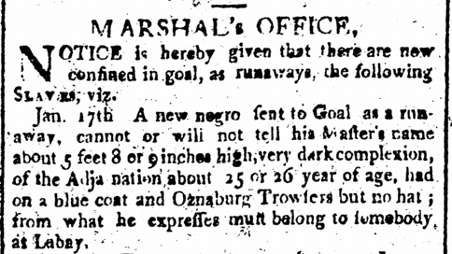
- A newly arrived African of the ‘Adja’ nation committed to the gaol.

Source: St. George’s Chronicle and Grenada Gazette, 15 February 1799, Caribbean Newspapers 1, 1718-1876.

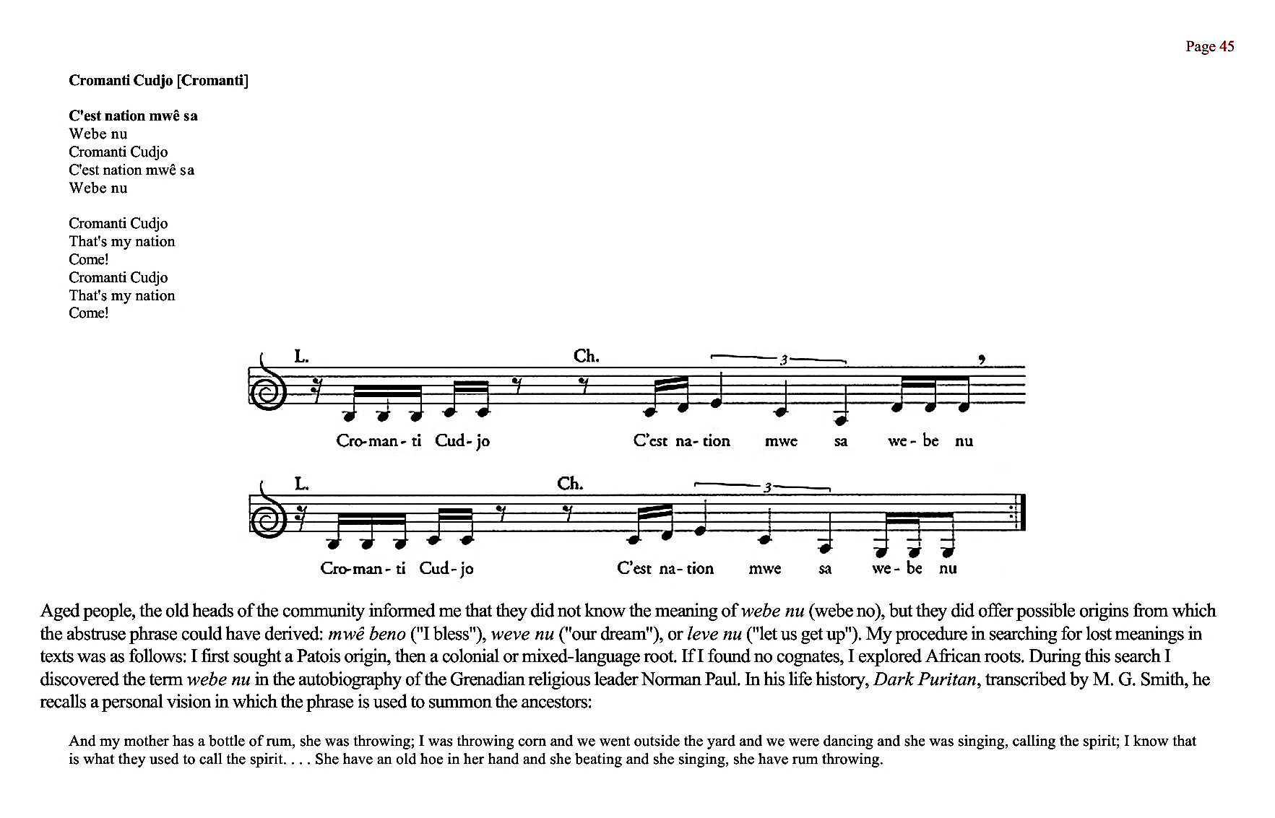C) Nation Dance song: ‘Cromanti Cudjo’
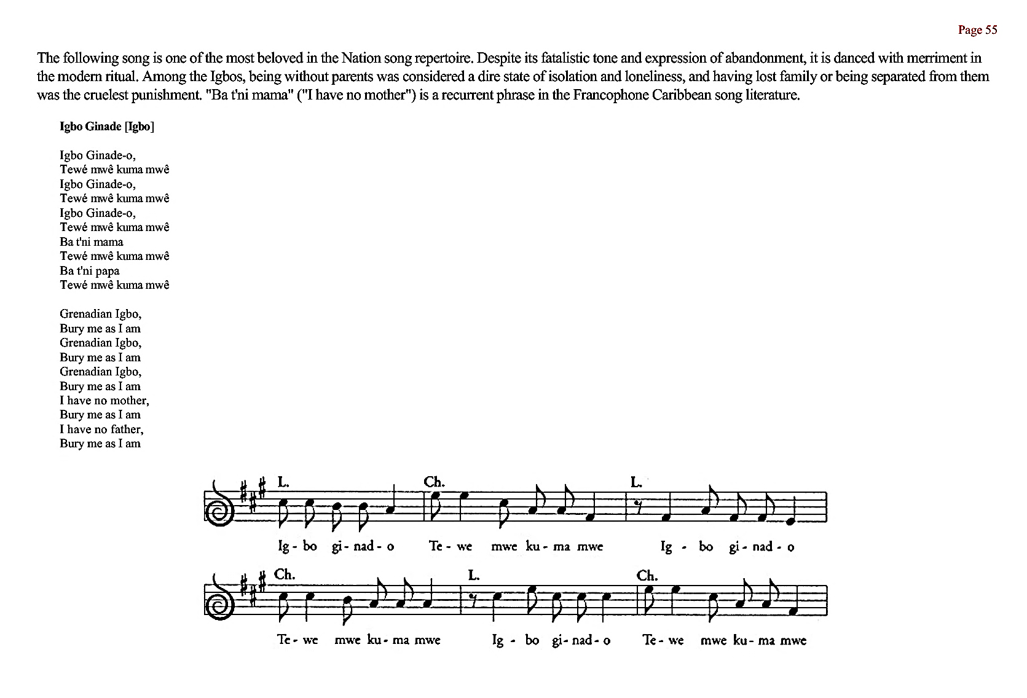
D) Nation Dance song: ‘Igbo Ginade’
Source for both songs: Lorna McDaniel, The Big Drum Ritual of Carriacou: Praisesongs in Rememory of Flight (Gainesville, Fla: University Press of Florida, 1998).
With thanks to Dr Shantel George for these sources. See https://www.gla.ac.uk/schools/humanities/research/historyresearch/researchprojects/grenadaheritage/ for more information.

