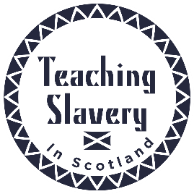

Equiano’s visit to the Plymley household in 1793

Mr Vasa [Equiano] had been on a visit to Mr Leighdon in Shrewsbury & was not, he said, willing to leave the county without seeing my Brother, to whom he had been introduced in London. My Brother had then purchased of him the memories of his life [The Interesting Narrative] written by himself; & I believe his business at this time was to get introduced wherever he could, & to dispose of them. My Brother was rather concerned at his going through the country for this purpose; as he feared it would only tend to increase the difficulty of getting subscriptions when wanted, for carrying on the business of the abolition. The luke-warm would be too apt to think if, this be the case, & we are to have Negroes come about in this way, it will be very troublesome. My brother thought there was something not quite right about him or he would have been at Sierra Leone. Be that as it may, had my brother been at home, he would have done all he could for him, & did endeavour to see him afterwards in Shrewsbury but he was gone. He dined at my Brothers, the little people, though they had not been accustomed to blacks, immediately went to him, offered their hands & behaved in their pretty friendly way. Whilst my sister was out of the room he gave Panton one of the little pamphlets against the use of sugar. When Ann return’d & Panton said, see what this gentleman has given me, she told him what warm friends they were to the abolition, & that they had long left off sugar. He gave Panton one of his memoirs & wrote his name in it himself, & desired him to remember him. He asked Panton if he should like to travel. P— said he did not know – Should he like to go to Africa – Yes – Will you go with me – just as my Papa pleases – Josepha on being asked made the same answer & he made many professions of the care he would take of them. Ann, Mrs. Plymley and the little people were much pleased with him. He has been since at Longnor but was again unfortunate in not meeting with my Br who, as he is still engaged and indefatigable in his parochial visitations, is much out. My Br wrote letters of recommendation for him there.

With thanks to Dr Ryan Hanley for this source.

