

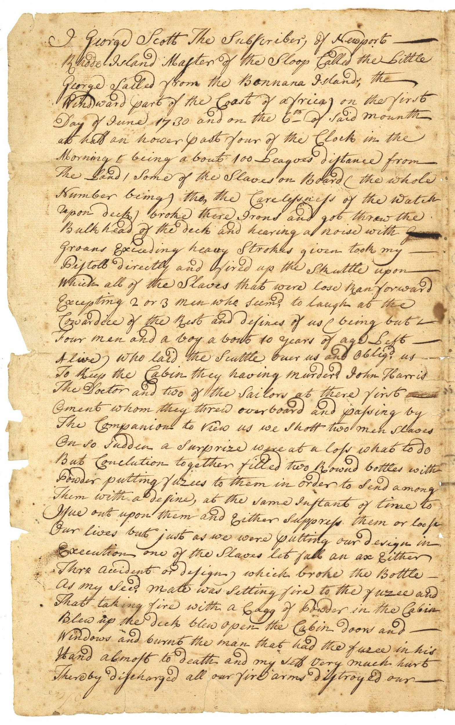

““I George Scott the subscriber, of Newport, Rhode Island Master of the Sloop called the Little George sailed from the Bonnana Island; the windward part of the coast of Africa on the first day of June 1730 and on the 6th of said month at half an hour past four of the clock in the morning & being about 100 leagues distance from the land / some of the slaves on board (the whole number being, tho, the carelessness of the watch upon deck) broke there irons and got threw the bulk head of the deck and hearing a noise with groans exceeding heavy strokes given took my pistol directly and fired up the shuttle upon which all of the slaves that were lose ran forward excepting 2 or 3 men who seemed to laugh at the cowardice of the rest and defines of us.”

From Testimony of George Scott, page 1. Rhode Island Historical Society Collections, MSS 17 Harris Family Papers, Box 2 Folder: 1730, Narrative of Slave Revolt on Ship off Africa.
http://library.providence.edu/encompass/rhode-island-slavery-and-the-slave-trade/primary-sources/narrative-of-slave-revolt-on-ship-off-africa/

Use www.slavevoyages.com to answer the following questions.

- Can you identify the vessel in the transatlantic slave trade database? Voyage ID:

- African port of departure:

- How did the enslaved people organize their revolt?

