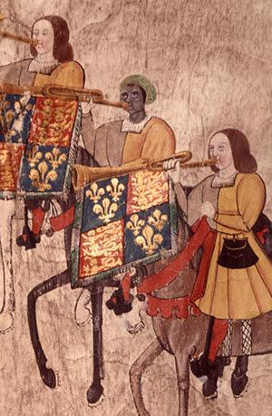
Source A - John Blanke
John Blanke (?-?) was a royal musician during the reigns of King Henry VII and King Henry VIII of England. He is currently the only black person from the Tudor period to be depicted in an image. From evidence, he was described as black and can be seen as such in the painting of him and other royal trumpeters. His turban suggests he was of Islamic origin. His skin colour was not a barrier to having a royal role at this time.
It is possible that John Blanke arrived in England with Katherine of Aragon in 1501. Katherine was initially intended to marry Prince Arthur, the oldest son of King Henry VII. However, Arthur's untimely death led to her marriage to Henry VIII. This context sheds light on the potential circumstances of John Blanke's arrival and his role in the Tudor court.
College of Arms MS Westminster Tournament Roll, 1511.
Blanke was not an enslaved person. Evidence shows him receiving a monthly salary from the Royal Court—just as much as a skilled craftsman would. He is not the only black musician on record to serve a royal court. There are sources that the Holy Roman Emperor Henry VI had black trumpeters in the 12th Century, and King James VI of Scotland employed a Muslim Moor drummer in the 16th century.
Blanke petitioned Henry VIII for a promotion and was granted this job. His wages doubled as a result. In 1512, he got married, and Henry VIII gifted him a wedding outfit. It would appear from the records that he married an Englishwoman and possibly converted to Christianity.
We have no records of how or when John Blanke died. He was a significant figure in black British history, reminding us of black people's contributions to British history.
(Paraphrased and adapted from: https://www.hrp.org.uk/tower-of-london/history-and-stories/john-blanke/#gs.8i3kcm)

Source B - Descriptions of Benin
Source B was written by a Portuguese visitor to Benin in the 1500s who wrote about what he saw.
Source B

Great Benin, where the King resides, is larger than Lisbon, all the streets run straight and as far as the eyes can see. The houses are large, especially that of the king which is richly decorated and has fine columns. The city is wealthy and industrious. It is so well governed that theft is unknown and the people live in such security that they have no door to their houses.
(Found in: Apps, K. (2021) Inventing Race? Year 8 uses early modern primary sources to investigate the complex origins of racial thinking in the past, Teaching History 183, June 2021.)
Source B is just one of several positive accounts of the grand cities of West Africa. Several well-developed and flourishing cities were to be found.
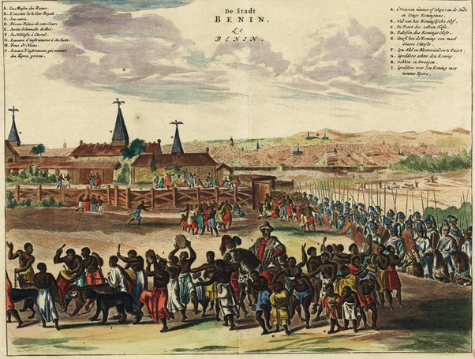
A depiction by a Dutch artist of the city of Benin, 17th Century.
(Published in Olfert Dapper’s Naukeurige beschrijvinge der Afrikaensche gewesten.)
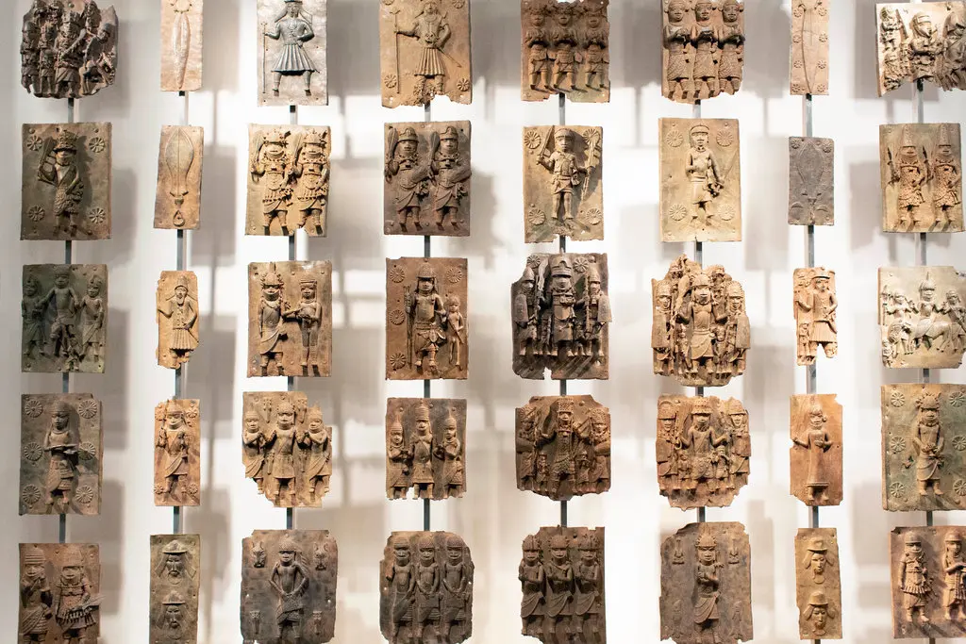

Some of the Benin Bronzes from the exhibition in the British Museum. These were used as a visual history of all of Benin's Obas (rulers). Many were taken after the British invasion of the city in 1897.
(From https://www.nytimes.com/2020/01/28/opinion/looted-benin-bronzes.html )

Source C - The Moroccan delegation
Source C is from Thomas Bernhere, an English merchant who described the Moroccan ambassador to Britain in c.1600.
Source C

The Ambassador is well learned and has an interest in experiments mathematical he is much delighted in the study of astronomy and astrology… your magnetical instrument of declination would be commodious for a yearly voyage, which some make for the King over a sandy sea (wherein they must use needle and compass) to Gao.
(Found in: Apps, K. (2021) Inventing Race? Year 8 use early modern primary sources to investigate the complex origins of racial thinking in the past, Teaching History 183, June 2021.)
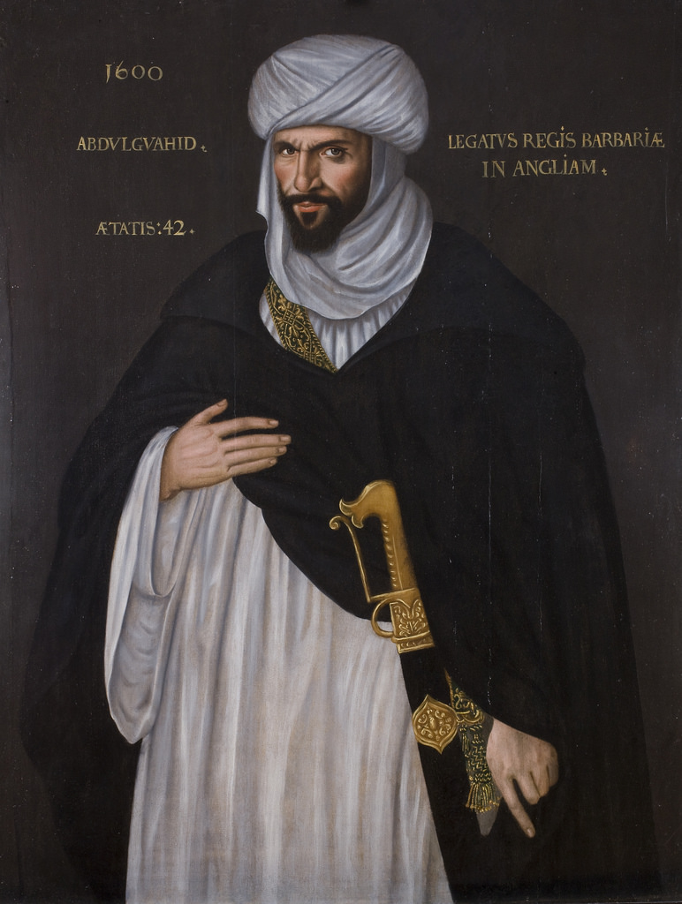
Abd el-Ouahed Ben Messaoud, mentioned in Source C, was a Moroccan ambassador with connections to Queen Elizabeth I's royal court. With such a significant status, he would have been respected and treated well.
This suggests that people of African origins could hold positions of power and have those positions recognised in European states and countries. Source C notes that he is recognised for his education and knowledge of complex topics, the understanding of which was still developing.
There is an unproven theory that Messaoud inspired Shakespeare’s main character, Othello. This is relevant as Othello was a negative depiction of a black or ‘Moorish’ person from well before 1650 - Othello is unable to control his emotions, becomes overwhelmed by jealousy and kills his wife.
(http://www.tate.org.uk/whats-on/tate-britain/exhibition/east-west-objects-between-cultures/east-west-room-1 )

Source D - Iberian/Muslim understanding of race

James H. Sweet (pictured on the left) argues that the Spanish and Portuguese (Iberian) understandings of race, later adopted by the British, were rooted in prior Islamic understandings of slavery and race.
As early as the 9th Century, Muslim traders were categorising their enslaved people based on their skin colour and assigning values on this basis. White-skinned enslaved people were seen as more valuable and were given less laborious jobs, such as house servants. Meanwhile, black-skinned enslaved people were seen as less valuable and, therefore, were ‘expendable’ and could be given more labour-intensive jobs such as daily hard labour.
https://jameshsweet.com/
This is not necessarily because of characteristics associated with skin colour or because one was seen as superior to the other. Instead, the Muslim traders’ reasoning was that white enslaved people were Christians and could be used as a ransom, which increased their value. They were given lighter jobs because they needed to be kept alive in case they needed to be ransomed.
However, because of this, most enslaved people who were sent to Europe from the Muslim slave trade were black. Therefore, the only time that white Europeans saw black people was when they were in a position of ‘inferiority’ or service to white people. This then began to shape and enforce the view that black people were inferior or a class of enslaved people.
(Sweet, James H. (1997) The William and Mary Quarterly, Jan., 1997, Vol. 54, No. 1, Constructing Race (Jan., 1997), pp. 143-166)

