Religious justifications of racism - The Story of Ham

Source A is from the Bible, particularly Genesis 9:18–27.
Source A

18 The sons of Noah who came out of the ark were Shem, Ham and Japheth. (Ham was the father of Canaan.) 19 These were the three sons of Noah, and from them came the people who were scattered over the whole earth.

20 Noah, a man of the soil, proceeded[a] to plant a vineyard. 21 When he drank some of its wine, he became drunk and lay uncovered inside his tent. 22 Ham, the father of Canaan, saw his father naked and told his two brothers outside. 23 But Shem and Japheth took a garment and laid it across their shoulders; then they walked in backwards and covered their father’s naked body. Their faces were turned the other way so that they would not see their father naked.

24 When Noah awoke from his wine and found out what his youngest son had done to him, 25 he said, ‘Cursed be Canaan! The lowest of slaves will he be to his brothers.’

(New International Version)

During the Transatlantic Slave Trade, the story of Ham in the Bible was used by some to justify racial categorisations. Christians at this time argued that black people descended from Canaan, the son of Ham, and as a result, were cursed as a population. They also used it to condemn African people to slavery, as (as you can see in the above passage from the Bible) Canaan was condemned to be a ‘slave’. This was then used to support the belief that African people were inferior and that white Europeans should be allowed to assume the position of ‘master’.

The first written account, in which the story of the Curse of Ham was used to justify slavery, came from Gomes Eanes de Zurara, a Portuguese historian from the 15th century. He wrote that captive Africans were in such a terrible state “because of the curse which, after the Deluge, Noah laid upon [Ham]… that his race should be subject to all the other races of the world”.

In 1627, an English author and defender of the slave trade wrote:
“This curse to be a servant was laid, first upon a disobedient son, Ham, and we see to this day, that [Black people], Ham’s [descendants] are sold like slaves yet.”
(Adapted from: https://theconversation.com/the-curse-of-ham-how-people-of-faith-used-a-story-in-genesis-to-justify-slavery-225212#:~:text=For%20almost%20500%20years%2C%20priests,the%20trans%2DAtlantic%20slave%20trade.)#

‘Scientific’ racism - Linnaeus’ Systema Naturae
(Rephrased from: https://www.linnean.org/learning/who-was-linnaeus/linnaeus-and-race-easy-read)
In 1735, Carl Linnaeus, then 28 years old, published Systema Naturae, his most famous work. For the first nine editions (1735-1756), Linnaeus classified humans into four "varieties":
- European white
- American reddish
- Asian tawny
- African black
These categories matched the four continents known at that time: Europe, America, Asia, and Africa. In the tenth edition, Linnaeus added more details to these human varieties. He described their:
- Skin colour, medical temperament, and body posture;
- Physical traits relating to hair colour and form, eye colour, and distinctive facial traits;
- Behaviour;
- Manner of clothing;
- Form of government.

Source B


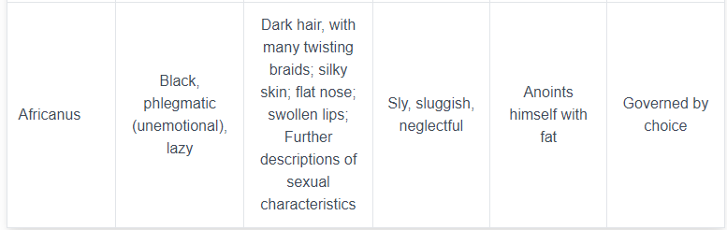

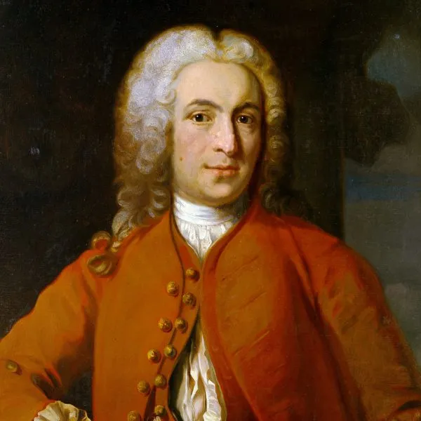
These descriptions were not based on real evidence but rather on supposed observations. Linnaeus ranked these groups, consistently placing the African variety at the bottom. His descriptions of African people were the longest and most negative, associating them with bad traits. This ranking stuck and had a lasting impact.

Linnaeus' classifications suggested that each human variety had specific traits, influencing how others viewed and treated these groups. As an important figure in natural science, other scholars took his ideas seriously.

Believing that some groups are inferior to others can lead to dangerous ideas, like those that justify genocide. Linnaeus’s work was used in harmful ways by future generations. Another problem was when Linnaeus' work was translated from Latin to English in 1792. The term "varieties" was changed to "sub-species," suggesting greater group differences and reinforcing racist ideas.

(Picture: https://www.linnean.org/learning/who-was-linnaeus/career-and-legacy )

