Resource Sheet 2 Play
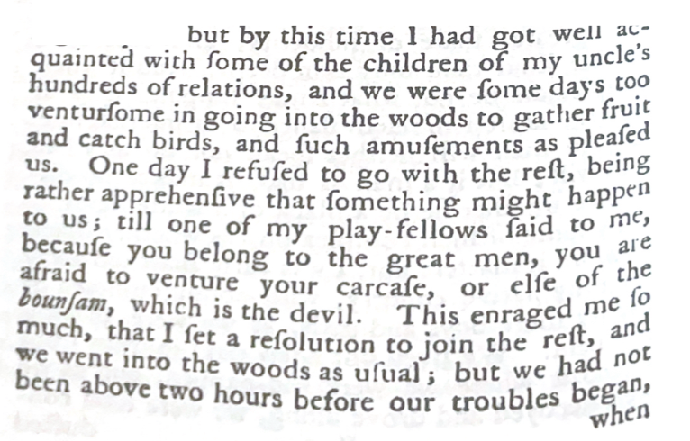
Extract from Thoughts and Sentiments of the Evil and Wicked Traffic of the Slavery and Commerce of the Human Speicies by Ottobah Cuguano: CUP, 2013.
